**SQL Assesment**

1. **Write sql query to find the items whose prices are higher than or equal 250rs. Order the result by product price in descending, then product name in ascending. Return pro_name and pro_price.**

SELECT pro_name, pro_price

FROM product

WHERE pro_price >= 250

ORDER BY pro_price DESC, pro_name ASC;

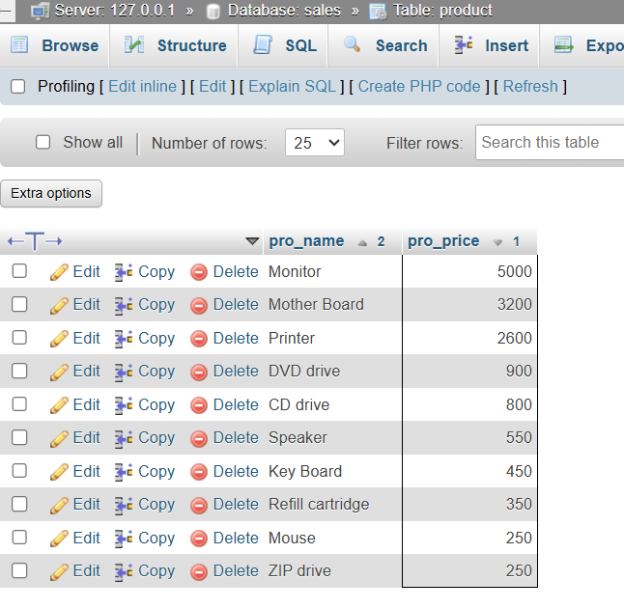

1. **Write a sql query to find the cheapest item. Return pro_name and pro_price.**

SELECT pro_name, pro_price

FROM product

ORDER BY pro_price ASC

LIMIT 1;

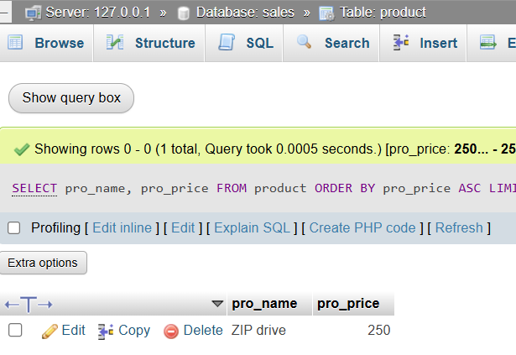

1. **Write the sql query to calculate the average price of the items for each company. Return average price and company code.**

SELECT company_code, AVG(pro_price) AS average_price

FROM product

GROUP BY company_code;

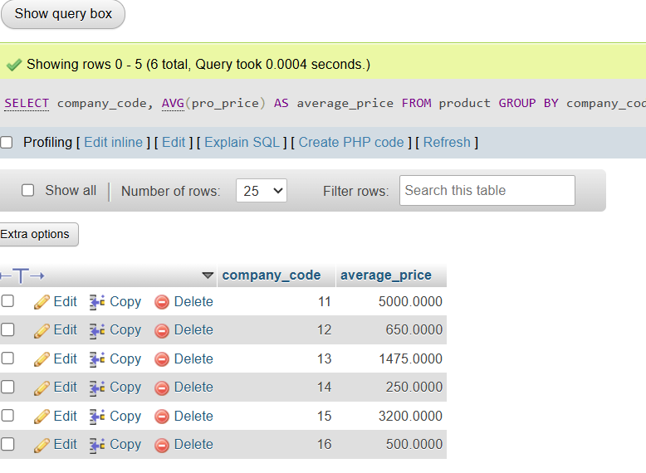

1. **Write the sql query to find the average total for all the product mention in the table.**

SELECT AVG(pro_price) AS average_total_price

FROM product;

